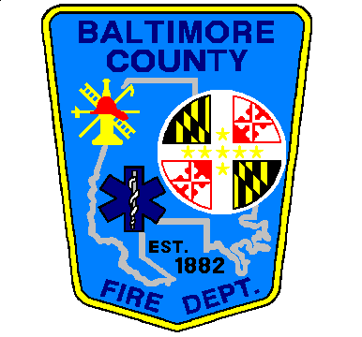
BALTIMORE COUNTY FIRE DEPARTMENT
Interoffice-Correspondence

Date: October 27, 2014
To: All Field Personnel
FROM: Michael W. Robinson, Division Chief
SUBJECT: Early Dispatch Implementation

It has now been nearly a month since the implementation of the Early Dispatch initiative. (See attached email.) The goal of this process has been to get emergency services to the citizens of Baltimore County quicker. Our data clearly shows the changes have resulted in us getting to our customers sooner. The concept surrounding this procedure has been validated by other jurisdictions in the region and nationally. We will continue to validate this process and expand its utilization where indicated.

With any new procedural change, questions and issues can arise that must be identified and resolved. There are currently several levels of quality assurance already in place, including the department’s Response Committee, which is comprised of career and volunteer members. However, we must all share in this responsibility to ensure this process is a positive change that will result in more efficient and expeditious service to our citizens.

To that end, we will be immediately implementing a feedback form, Early Dispatch Discrepancy (Form 60). This form is attached and is also available in the Fire Department’s Forms Library on BCnet. This form shall be utilized as the primary means to notify the Response Committee of any discrepancies regarding the dispatch of units relative to the Early Dispatch process. The form should be completed as indicated, with as much information as possible, and sent electronically to Fire_ADO@baltimorecountymd.gov. Once received, the form, incident, and dispatch records will all be reviewed and a response provided to the originator. This will also provide relevant data that will lead to quality improvement and assurance of our goal to provide a more efficient and relevant dispatch process, consistent with incident needs. Please contact me with any questions or concerns.

Sent August 13, 2014
***This email is being sent under the authority of Assistant Chiefs Hubbard and Preis***

All Personnel,
In the coming months, the Baltimore County 911-Communications Center will be implementing an early dispatch protocol for emergency calls. Following feedback from field operations personnel, the Fire Department and the Communications Center worked together to develop this protocol. This will enhance our operations and allow EMS and fire units to begin moving to the scene in a timelier manner, reducing response times. Upon receipt of the initial call type and location, units will be dispatched while the 911 call taker continues to gather information. Initial dispatch information may be limited to the location and type of call only. What this means is, while you are responding, the 911 call taker is still on the line with the caller getting more information. This additional information will be relayed to you when it is received. Please be patient with the dispatchers. There may be times where a call is upgraded while initial units are enroute, based on further information.

As with any new procedural change, issues can arise. They should be addressed through the chain of command. If the issue is EMS related, work through your respective EMS District Officer. If it is fire related, work through your respective Battalion/Division Chief.

BALTIMORE COUNTY FIRE DEPARTMENT

Communications Division

EARLY DISPATCH DISCREPANCY

(email Form to fire_ado@baltimorecountymd.gov)

Incident #: Unit ID: Date:

911 Connect time: Dispatch time:

Type of incident:

Box: Location:

Description of discrepancy:

Incident Disposition:

Incident upgraded: Incident downgraded:

Situation found on arrival:

Submitted by: (name/title/station)

Do not write below this line:

Reviewed by: Date:

Outcome:

